Women Fortune Tech Internship
Maryam Rehan
Week #01
Assignment:01 Network Reconnaissance Using Nmap
Introduction:
Network reconnaissance is an important first step in cybersecurity and network security assessment. It involves gathering information about systems and devices connected to an authorized network. In this practical task, Nmap was used to identify active hosts, scan a target system, and detect open ports and running services within an authorized VirtualBox lab environment.
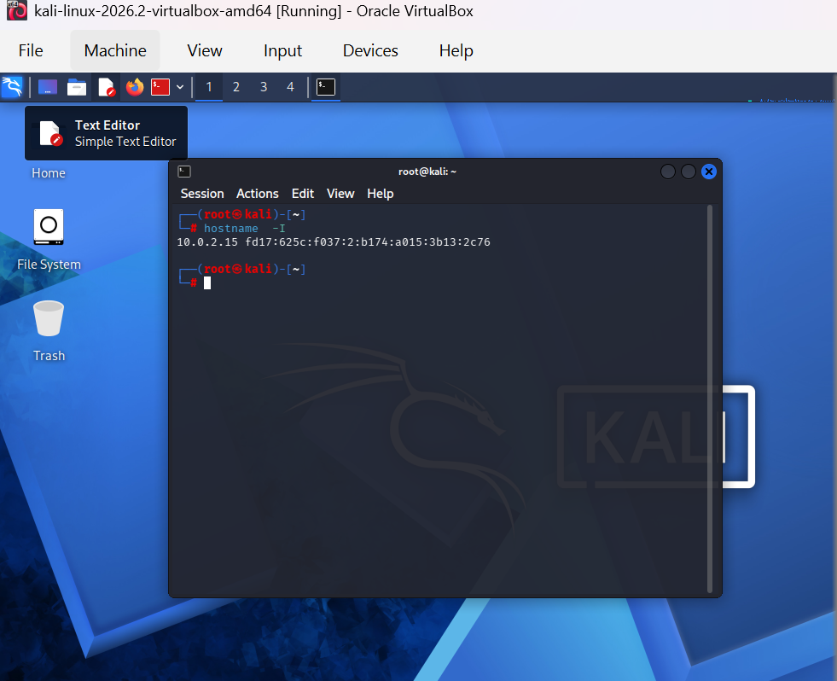
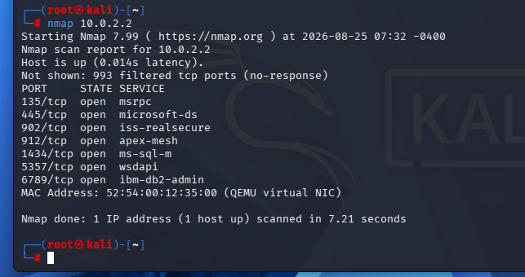
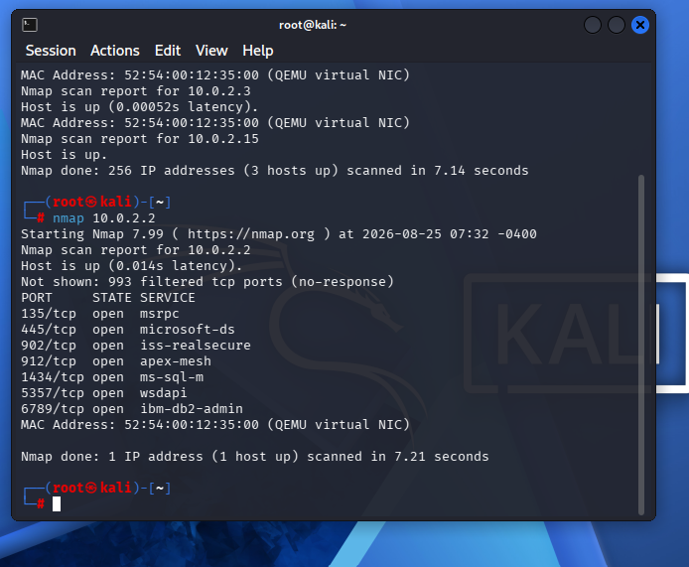
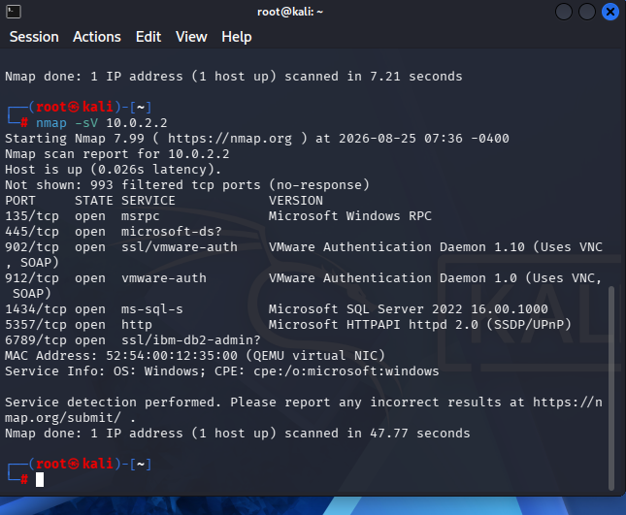
Findings:
The IP address of the Kali Linux system was identified as 10.0.2.15. A host discovery scan was performed on the 10.0.2.0/24 authorized lab network, which identified three active hosts: 10.0.2.2, 10.0.2.3, and 10.0.2.5.
A basic Nmap scan was then performed on the authorized host 10.0.2.2. The scan revealed several open ports, including 135 (Microsoft RPC), 445 (Microsoft-DS), 902 and 912 (VMware Authentication), 1434 (Microsoft SQL Server), 5357 (Microsoft HTTPAPI), and 6789. Service version detection indicated that the target was a Windows-based system.

Conclusion:
This practical task demonstrated how Nmap can be used for basic network reconnaissance in an authorized environment. The scans successfully identified active hosts, open ports, and services running on the selected target system. This information is useful for understanding the network environment and identifying services that may require further security assessment and monitoring.

